Action Research Project
TE893
Annie Boggs
Gering Public Schools 7-12

Introduction/Description of Weakness or Problem

Will the implementation of an eBook lending library increase student reading and improve literacy? Currently, Gering Public Schools, does not have an eBook lending vendor. Gering Public Schools is comprised of three K-6 elementary schools, one k-4 elementary school, a 7-9 junior high school library and a 10-12 high school library. The total number of print copies in the Destiny Library System is 66,180 and the current library check outs are 2,725 or 4 percent. The junior high and high school libraries have 73 Kindle devices with over 100 titles to choose from. However, not one of the titles can be found using the Destiny Library System. Would library circulation increase if the district offered eBook lending? Our Destiny Library System is a web based system that offers 24/7 access. Would library patrons check out eBooks during non operational hours? Will there be a target age for the lending of eBooks? What device will the patron use when checking out an eBooks? Will the benefits of eBooks outweigh the cost? There are many questions that need to be answered. This research will be based upon the 7-12 library environments. The changing role of the 21st century library encourages technology related literacy. The school librarian models use of state of the art and emerging technologies by applying learning theory to identify applications that enhance the learning process. (AASL , 2010)

Data Collection

In today’s world of data-driven decision making, the library media specialist must develop the skills to work with his or her staff in using data for program improvement. (“Why Action Research”, 2005) The data collection for eBooks will be collected using blogs, vendor websites and sales personnel, surveys and interviews. As of April 2013, all of the “Big Six” publishers are now engaged in library e-lending pilots or provide some/all of their titles for purchase by libraries. (“E-Book Media and Communications Toolkit”, 2013) Data for the action research project was collected from vendors, students and administrators. The following sources were used to collect the data.
- www. booksarejustthebeginning.com blog,
- www.overdrive.com/education/k-12-schools/,
- www.overdrive.com/files/Publications/EducationalContent.pdf.
- http://btol.com/axis360/schools.htm
- http://solutions.3m.com/wps/portal/3M/en_US/library-systems-NA/library-technologies/library-solutions/
- http://www.aboutfollettebooks.com/follettshelf.cfm
- The high school student librarians with the help of Mrs. Boggs conducted a 7-12 student survey. The survey was posted online at http://ghs.geringschools.net/ and was taken to the classrooms in a print format. 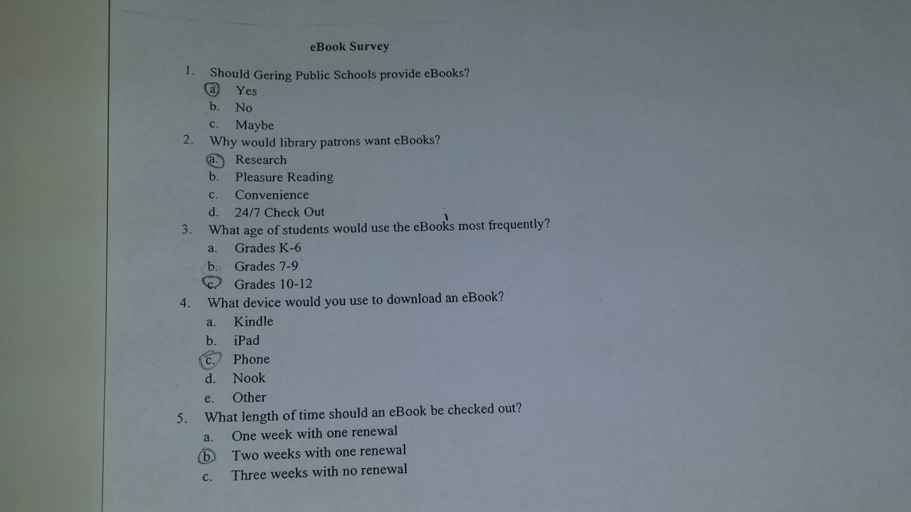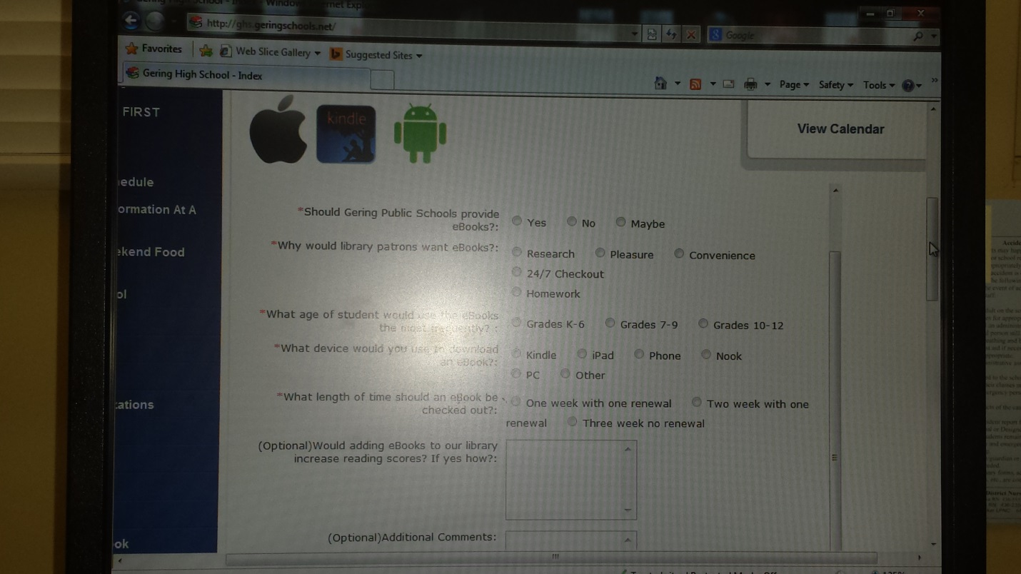
- Informal Interview with the high school principal, Eldon Hubbard.
  - How do you feel about the implementation of eBooks in our district? “I love the feel of a book. However, it would definitely be beneficial for travel. If the purchase of eBooks would increase reading scores and decrease cost I would say, let’s do it.”
  - We currently have 73 kindles but we have purchased the eBooks and they aren’t in our current library system. How do you feel about the librarian having sole control over those eBooks. “I did not realize how it all worked but I like the idea of a student having the ability to check books out 24/7”.
  - Do you have a preference in regards to an eBook vendor? “I would like to offer an opinion but I will leave those decisions up to someone with more knowledge of the situation. “
- Informal interview with the Freshman Academy Principal, Kraig Weyrich.
  - How do you feel about the implementation of eBooks in our district? “Personally, I would rather hold an actual book. However, I see the need for eBooks. I feel like it would reduce cost.”
  - Do you have a preference in regards to an eBook vendor? “No, I haven’t done any research.”

Organization and Interpretation of Data
Based on the data I would recommend that our district purchase eBooks for the junior high and high school libraries from Overdrive. The five year technology plan for Gering Public Schools is for every student to have access to a device. That device might be a Chrome Book, iPad or a Kindle. We collected 261 student surveys. The students ranged from grades 7-12.

- Should Gering Public Schools provide eBook lending?
60% Yes | 15% No | 24% Maybe

- Why would library patrons want eBooks?
52% Convenience and 24/7 check out. | 25% Research | 25% Pleasure reading

- What age of students would use the eBooks most frequently?
63% 10th-12th Grade | 32% 7th-9th Grade | 5% K-6th Grade

- What device would you use to download an eBook?
34% Phone | 26% iPad | 24% Kindle | 8% Nook | 8% Other

- What lending period should be provided for the eBooks?
38% Three weeks with no renewal | 33% Two weeks with one renewal | 29% One week with one renewal

According to the chart, 60% of students want eBook lending added to the junior high and high school libraries. The patrons would use eBooks primarily because they are convenient and can be checked out 24 hours a day, seven days a week. Not surprisingly, our students would download the eBooks to their phones. Most students believe in a three week check out period with no renewals. The 36 comments from the survey were beneficial in the decision making process.
Based on the informal interviews with our high school principal and our assistant high school principal I realize that I am the one in charge of research and education in the area of eBooks. If the purchase of eBooks would increase reading scores and decrease cost I would have support from my administration.
Thirdly, I was able to communicate with three different eBook vendors. Overdrive is the vendor used by the public libraries and another school district in our area. The vendor offers support for the Kindle, immediate access to the first 10% of many eBooks (even if someone else has it checked out), some books with simultaneous access and they are working to get links into the library catalogs. The second vendor is the Follett Shelf, this vendor works well with our Destiny Library System. However, our data reflects a strong desire for students to read for pleasure and convenience. Follett Shelf does not offer a good selection of Fiction titles. The third vendor for eBooks was the Baker and Taylor’s product, Axis 360. Axis 360 circulates eBooks through the free Blio™ app. The selling point for Blio is that they are full color and provide the same graphically rich experience you would have reading a print book. Axis 360 was appealing to me until I read the list of devices available for downloads and every device was listed except for the Kindle. I know that we can add the Blio app to the Kindle Fire device. However, our library offers the basic Kindle devices. The Axis 360 eBooks system also works well with the Alexandria Library System and we use the Destiny Library system. I really like this eBook vendor but I don’t think that it will work in our situation.
In summary, it is my data based recommendation that we purchase an eBooks lending program from Overdrive for the 2014-2015 school year. The fee schedule for our 7-12 libraries is $3,000 which includes a $1,500 dollar credit to be used for collection development. Currently, Overdrive is promoting a NO HOSTING FEE schedule. Therefore, the entire $3,000 would be used toward the purchase of eBooks. Service features that are included in the annual fee include: reporting services, authentication options, live web based staff training, secondary user support, secure website with custom collection, apps for eBooks, audiobooks, music and video, compatibility with the Kindle, Nook, and iPad and all major devices. eBook lending will increase reading and improve literacy for our students.

Implementation of Changes
Assessing, planning, and improving the library program is a collaborative process that should include major stakeholders in the program such as library professionals and support staff, school administrators, teachers, parents, and students. (AASL, 2010) As a result of the on line survey the local newspaper printed an article on our research. The interview took place on March 6, 2014 at 1:30pm. This action research project will be presented to my Principal, Eldon Hubbard, Assistant Principal, Kraig Weyrich, Jr. High Principal, Dora Olivares and the Head of Curriculum, Terri Martin. Following administrative approval my staff and I will go to work on the purchase, selection and implementation of the eBooks.
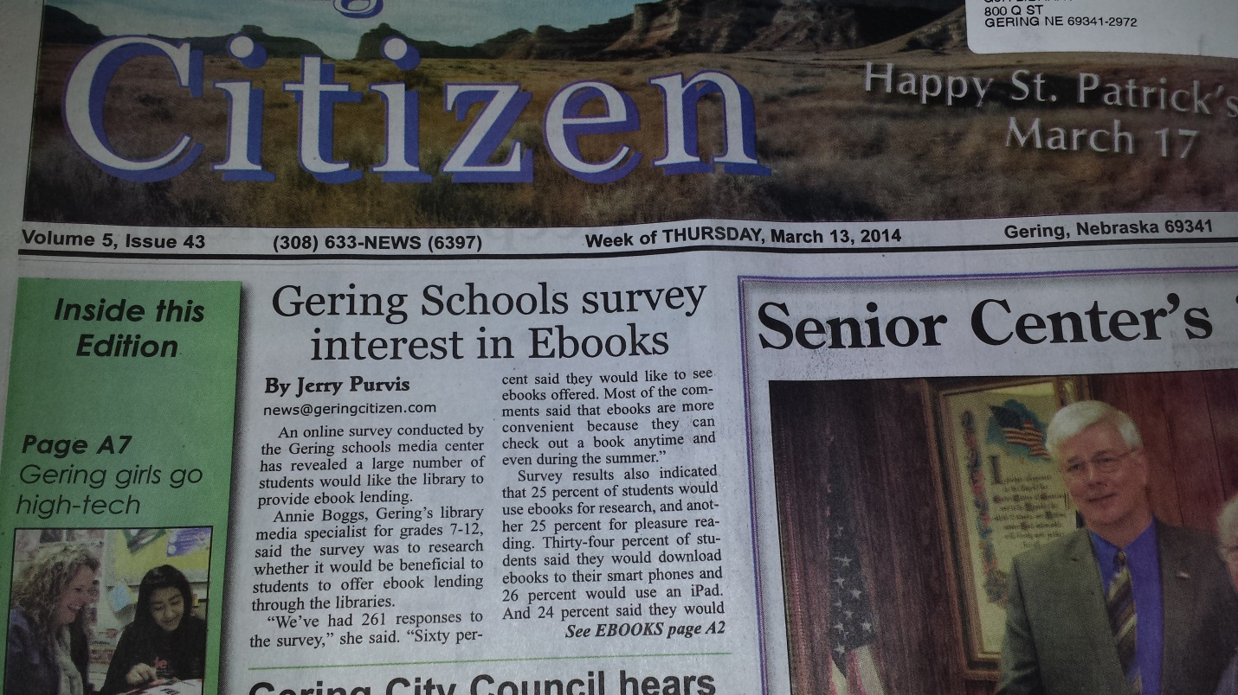

References
American Association of School Librarians. (2010). School library program assessment rubric. New York: Britannica Digital Learning.
Axis 360. (n.d.). Retrieved March 17, 2014, from http://www.btol.com/axis360/schools.htm
Books are Just the Beginning. (n.d.). Retrieved March 17, 2014, from http://www.booksarejustthebeginning.com/
EBooks for K-12 Schools. (n.d.). Retrieved March 17, 2014, from http://www.overdrive.com/education/k-12-schools/
Gering High School - Index. (n.d.). Retrieved March 17, 2014, from http://www.ghs.geringschools.net/
Home - Follett eBooks. (n.d.). Retrieved March 17, 2014, from http://www.aboutfollettebooks.com/follettshelf.cfm
Why Action Research? The Leadership Role of the Library Media Specialist. (2005). Library Media Connection, 24(2), 32-34.

